**Video Annotations:**

1. Choose a video from your local system using the choose button.
2. The video will start playing once you hit the start button in the browser. Here is a sample screen shot.

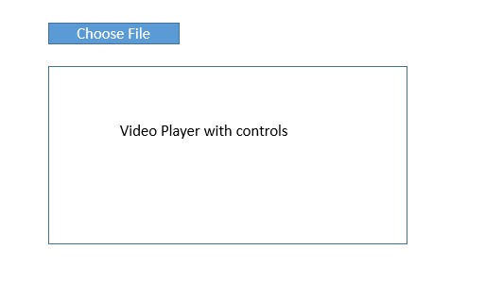

1. At the right hand side we have key short cuts panel where we give the feedback and press the key. Sample screen shot

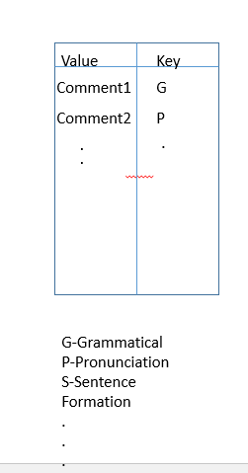

1. Once you give feedback and press the key then it automatically saves the comment and the key along with the time-stamp where the mistake is made.
2. Sample feedback panel is shown below.
3. It consists of all the time stamps along with the key, value.
4. It has a cross mark symbol, where he can delete the comment by pressing it.

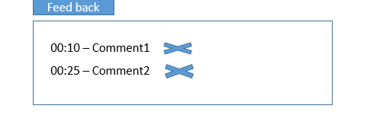

1. It continues till the end of the feedback. We can look at the history at any time as it scrolls down.
2. Mentor mode is done.
3. At the end we have a Done Button, which submits the feedback.



**Student Mode:**

1. The entire screen looks similar to the mentor mode apart from two extra features.
2. Features include Comments, and Challenge.

**Comments:**

Student can give a comment based on the feedback received.

**Challenge:**

Student can even challenge the mentor for the given feedback

Sample screen shot goes below.

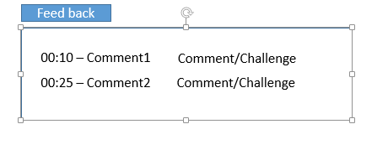

Fake Final Screen looks like this:

